**[Artificial Intelligence](https://classroom.google.com/u/0/c/NDUwNzE1NDkwMTg2" \t "_self)**

Lab Assignment – 1

Implementation of Toy Problems

**Name** – N Aditya Sai

**Register No**. – RA1911030010075

**Date** – 04.01.2022

**Question** - A person has 3000 bananas and a camel. The person wants to transport the maximum number of bananas to a destination which is 1000 KMs away, using only the camel as a mode of transportation. The camel cannot carry more than 1000 bananas at a time and eats a banana every km it travels. What is the maximum number of bananas that can be transferred to the destination using only camel (no other mode of transportation is allowed).

**Code** –

dp = [[-1 for i in range(3001)] for j in range(1001)]

def recBananaCnt(A, B, C):

    if (B <= A):

        return 0

    if (B <= C):

        return B - A

    if (A == 0):

        return B

    if (dp[A][B] != -1):

        return dp[A][B]

    maxCount = -2\*\*32

    tripCount = ((2 \* B) // C) - 1 if(B % C == 0 ) else ((2 \* B) // C) + 1

    for i in range(1,A+1):

        curCount = recBananaCnt(A - i, B - tripCount \* i, C)

        if (curCount > maxCount):

            maxCount = curCount

            dp[A][B] = maxCount

    return maxCount

def maxBananaCnt(A, B, C):

    # Function Call

    return recBananaCnt(A, B, C)

A = 1000

B = 3000

C = 1000

print(maxBananaCnt(A, B, C))

Screenshots:

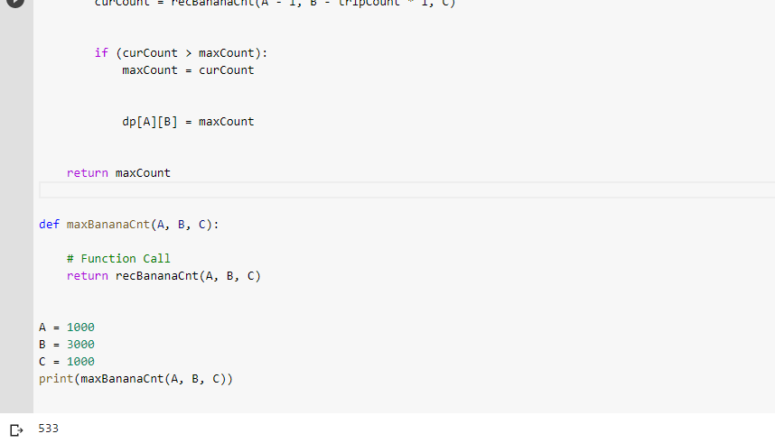

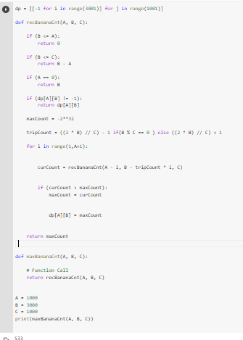

Result : The maximum number of bananas were calculated.